1. Open the image by using **ImageJ with Olympus Plugin**

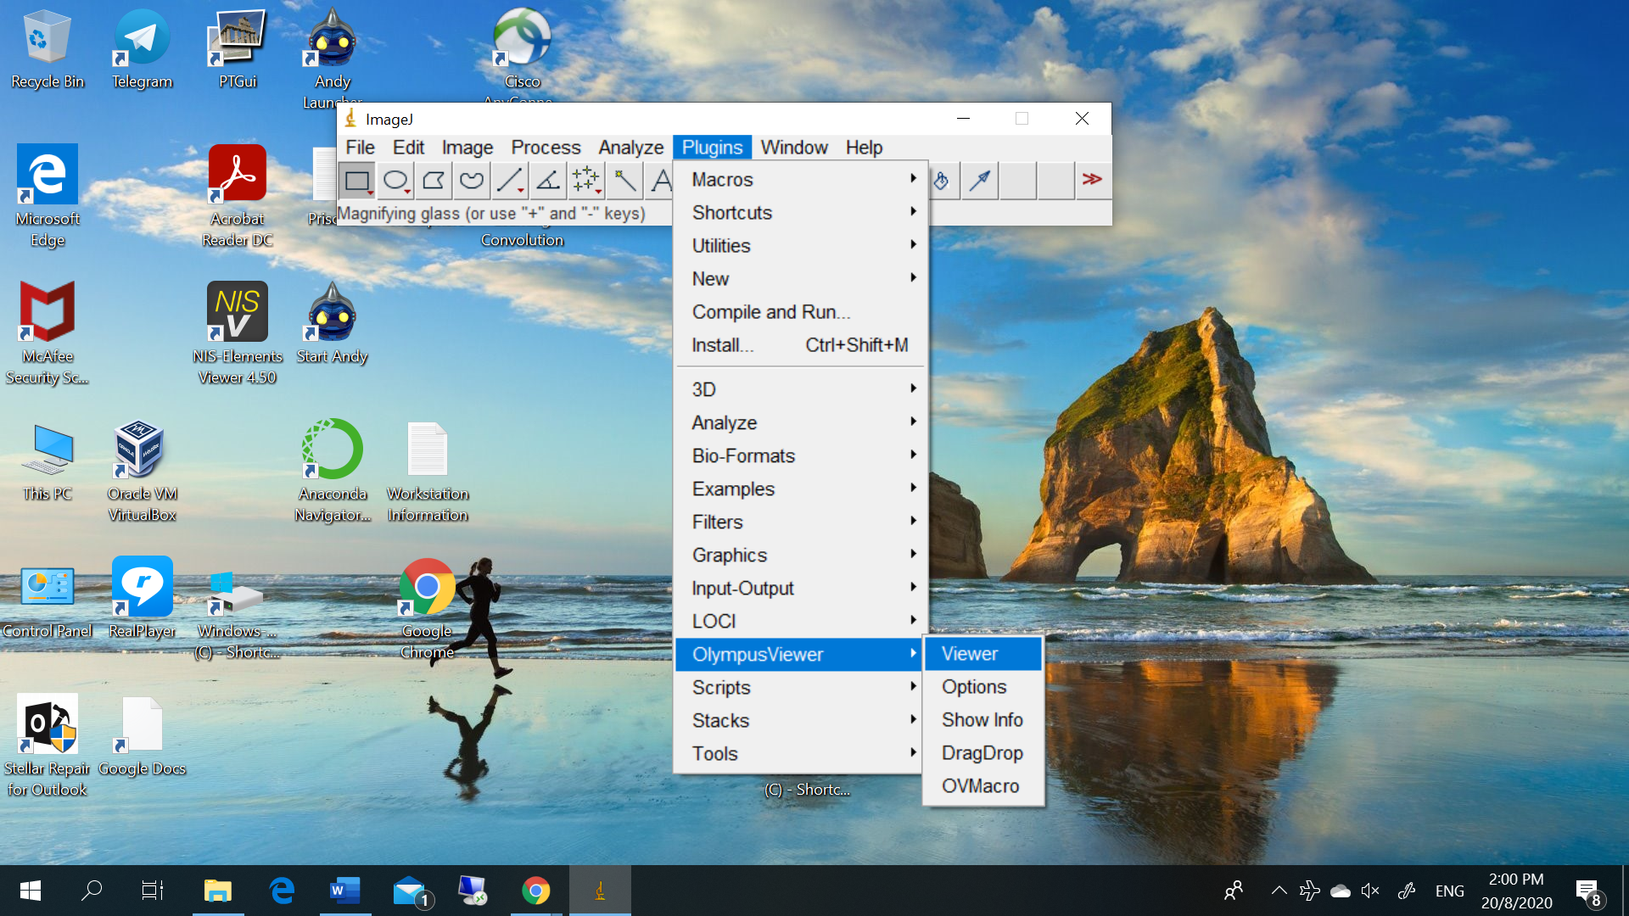

1. Choose the suitable image for viewing

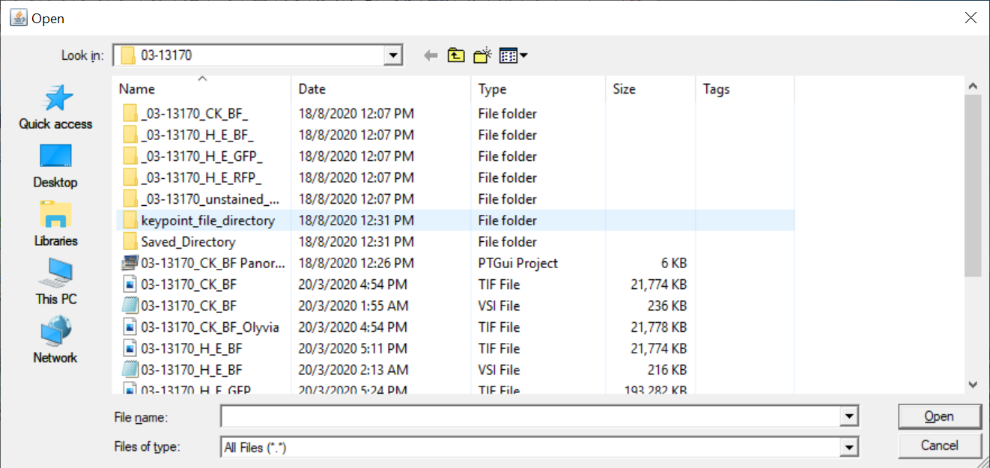

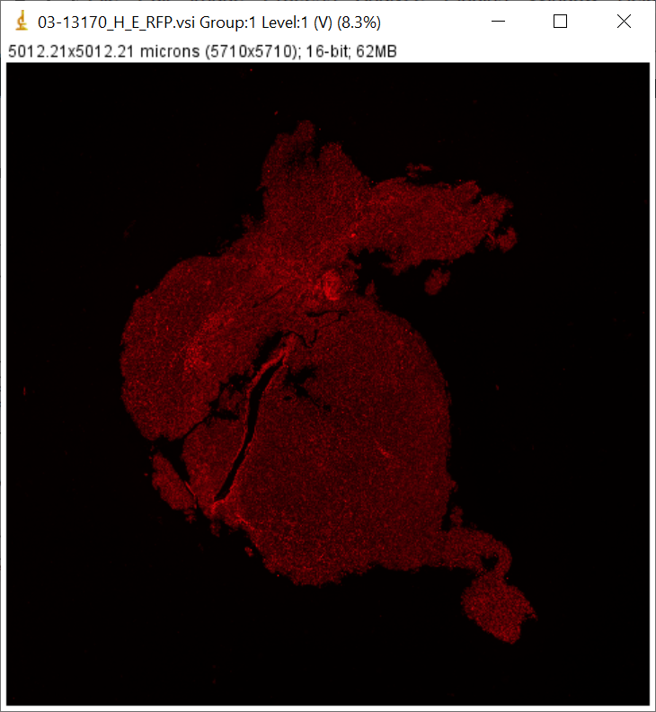

1. Originally the image is in 16 bit, when I try to change to RGB Color

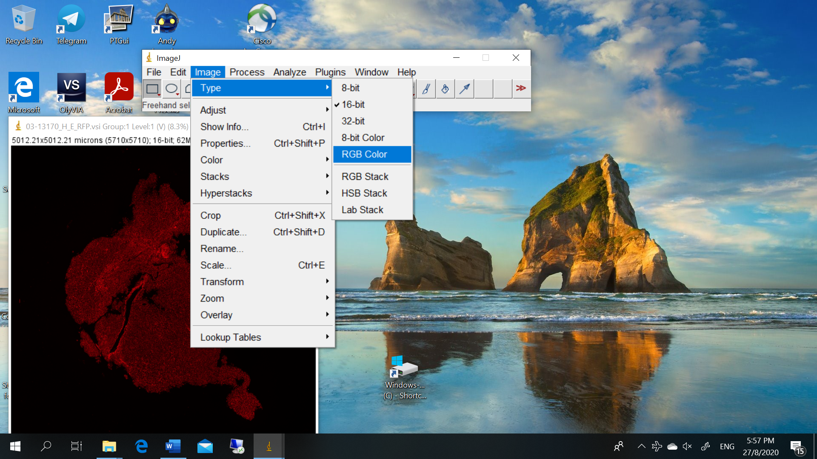

An error occur

